

WOLLO UNIVERISTY KOMBOLCHA INSTITUTE OF TECHNOLOGY

DEPARTMENT OF INFORMATION SYSTEM

SYSTEM ANALYSIS AND DESIGN PROJECT

Group members

Group Name Id Number

1, Mulualem Gelaw 0594/10

2, Lidiya Mekonen 0576/10

3, Hirut Wagnaw 0569/10

4, Azmera Tesfaye 0532/10

5, Zebider Gashaw 1260/09

6, Banchayehu Amare 0533/10

7, Bitew Tadege 1010/10

8, Belayneh Asefa 0535/10

9, Yohanis Testate 2289/10

10, Sehaladin Nuru 4848/10

**ACKNOWLEDGEMENT**

We take this occasion to thank God, almighty for blessing us with his grace and taking our endeavor to a successful culmination. We extend our sincere and heartfelt thanks to our esteemed guide, **Mrs.MulatuAstatkie**, for providing us with the right guidance and advice at the crucial junctures and for showing me the right way. support, valuable suggestions and guidance. We would like to thank the other faculty members also, at this occasion. Last but not the least, we would like to thank our friends and family for the support and encouragement they have given us during the course of our work.

**Table Of Contents**

***Table Of Contents***

*Abstract****………………………………………………………………….****3*

***Chapter1Introduction………………………………………………..……5***

*1.1 Project Aims And Objectives ……………………………………….5*

*1.2 Background Of Project………………………………………...........5*

*1.3 Operation Environment………………………………………….......6*

*1.5operational Enviromen……………………………………………….7*

*1.6 Schedule Feasiblity…………………………………………………...7*

***Chapter 2. System Analysis …………………………………………......…8***

*2.1 Existing System…………………………………………………….....8*

*2.2 Proposed System****………………………………………………..****8*

*2.3 Feasiblity Analysis* ***………………………………………..……****9*

*2.4 Technical Feasiblity……………………………………..………….9*

*2.5 Economic Feasiblity………………………….……..………………..10*

*2.6 Software Requairment Specificatio…………..……..…………..…10*

*2.6.1 General Discription…………………………………………….…10*

*2.6.2 System Objective………………………..………………………....11*

*2.6.3 System Requairment…………………………………………….…12*

*2.6.3.1 Non-Functional Requarment.………………………………….12*

*2.6.3.2 Functional Requairment………………………………………..13*

*2.6.4 Software And Hardware Requairment..………………..………..15*

*2.6.4.1 Software Requairment…………………………………………...15*

*2.6.4.2 Hardware Requairment……………………………………..…..15*

*2.7 Existing Vs Proposed System………………………………….….16*

***Chapter 3. System Design ....……………………………………………..17***

*3.1 Input Design****.…………………………………………………..****17*

*3.1.1 Input Data****…….......................................................................****17*

*3.1.2 Output Design………………………………………………………18*

*3.1.3 Database Design…………………………………………………..18*

*3.2 Table Design………………………………………………………….19*

*3.3 Data Flow Diagram…………………………………………………..22*

***Chapter 4. System Testing ………………………………………………….24***

*4.1 Unit Testing ……………….,…………………………………………24*

*4.2 Integration Testing……………………………………………..……26*

***CHAPTER 5. CONCLUSION & FUTURE SCOPE….…………………26***

***CHAPTER 6. REFERENCES ………………………………….………..26***

**ABSTRACT**

Library management system is a project which aims in developing a computerized system to maintain all the daily work of library .This project has many features which are generally not availiable in normal library management systems like facility of user login and a facility of teachers login .It also has a facility of admin login through which the admin can monitor the whole system .It also has facility of an online notice board where teachers can student can put up information about workshops or seminars being held in our colleges or nearby colleges and librarian after proper verification from the concerned institution organizing the seminar can add it to the notice board . It has also a facility where student after logging in their accounts can see list of books issued and its issue date and return date and also the students can request the librarian to add new books by filling the book request form.The librarian after logging into his account i.e admin account can generate various reports such as student report , issue report, teacher report and book report

Overall this project of ours is being developed to help the students as well as staff of library to maintain the library in the best way possible and also reduce the human efforts.

CHAPTER 1

# 1 .INTRODUCTION

This chapter gives an overview about the aim , objectives ,background and operation environment of the system.

**The main objective of the Library Management system is organizing and managing the library tasks. Library is place where all kind of books are available. This is a web base application and only a registered user can access the application. Library Management system is developed to automate the task of entering the records of new book and retrieving the details of book available in the library. This system contains list of all the books. Using this system user can issue book to the library member, maintain their records, and can checks how many book are issued and how many books are available in the library. This system provides separate interface and login for librarian, students and faculties. Librarian can modify database. Using the library management system, user can also maintain the late fine of library member who return the issued book after the due date.**

**Users can search for books and renewal books online. In the proposed system, we assume that each member will be having a identity card which can be used for the library book issue, fine payment etc. They can recommend for new books by just sending messages to the librarian from any where in the college. whenever library member wish to take a book, the book issued by the library authority will be check both the book details as well as the student details and store it in library database. They can view the issue and return dates of any book and due they have to pay.**

**1.1 PROJECT AIMS AND OBJECTIVES**

The project aims and objectives that will be achieved after completion of this project are discussed in this subchapter. The aims and objectives are as follows:

* Online book issue
* Request column for librarian for providing new books
* A separate column for digital library
* Student login page where student can find books issued by him/her and date of return.
  + A search column to search availability of books
  + A teacher login page where teacher can add any events being organized in the college and important suggestions regarding books.
  + Online notice board about the workshop.

loss of book record or member record which generally happens when a non computerized system is used.

In addition, report module is also included in Library Management System. If user’s position is admin, the user is able to generate different kinds of reports like lists of students registered, list of books, issue and return reports.

**All these modules are able to help librarian to manage the library with more convenience and in a more efficient way as compared to library systems which are not computerized.**

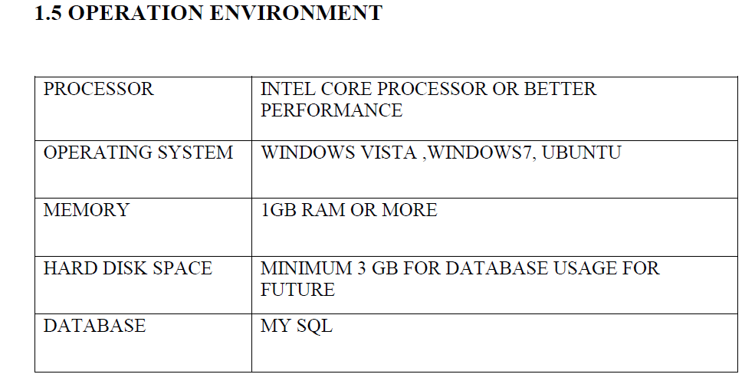

**1.6Schedule Feasibility**

**The schedule for this project will be feasible due to wealthy information exchange between the developing team, Advisor and the organization. And also the time set to develop the system is** **enough to complete at the predefined date and time. The project team members expected the project to be completed on time without any delay. And also the our team members accomplishe there task with agreatmotivation.**

**We do our project in amanner that with performance meace that the student who have an interpersonal skill accomplish interview and a studentswth thecnical skill participate in thecnical issue.**

|  |  |  |  |  |
| --- | --- | --- | --- | --- |
| NO | Task Name | Start | Finish | Duration |
| 1 | Proposal of project | 10/03/2011 | 22/03/2011 | **1W** |
| 2 | System analysis | 23/03/2011 | 07/04/2011 | **2W** |
| 3 | System design | 08/04/2011 | 29/04/2011 | **3w** |
| 4 | System implementation | 30/04/2011 | 10/05/2011 | **1W** |
| 5 | Testing System | 11/05/2011 | 19/05/2011 | **1W** |
| 6 | Conclusion and Recommendation | 18/05/2011 | 27/05/2011 | **1W** |

CHAPTER 2

# 2. SYSTEM ANALYSIS

In this chapter, we will discuss and analyze about the developing process of Library Management System including software requirement specification (SRS) and comparison between existing and proposed system . The functional and non functional requirements are included in SRS part to provide complete description and overview of system requirement before the developing process is carried out. Besides that, existing vs proposed provides a view of how the proposed system will be more efficient than the existing one.

2.1Existing system

System Analysis is a detailed study of the various operations performed by a system and their relation ship with and out side the system.

Here the key question is what all problems exist in the present system?

What must be done to solve the problem?

Analysis begin when a user or manager begins a study of the program using existing system?

During analysis data collected on the various files, dicision points and transaction handeled by the present system.

The common used tool in the system are data flow diagram, interview etc.

Training experience and common sence are required for collecton of relevant information needed to develop the system.he success of the system dependeslargly on how clearly the problem is defined thoroughly investigated and properly carried out thorough the choise of solution. A good analysis model shoude provide not only the mechanism of problem understanding but also the fraim work of the solution. Thuse it shoudbrestuded thoroughly by collecting data about the system.then the proposed system shoud be anlysed thoroughly in accordance with the needs.

System analysis can be categorized in to four parts:-

* System planning and initial investigation
* Information gathering
* Applying analysis tools for structured analysis
* Feasibility study
* Cost/benefit analysis

In our existing system all the transaction of books are done manual, so taking more time for a transaction like borrow a book or returning book and also for searching of members and books.

Another majer disadvantage is that to preparing the list of books borrowed and the available books in the library will take more time currently it is doing as a one day process for verifying all recordes.so after conducting the feasibility study we desided to make the manual library management system to be computerized.

2.2Proposed system

can add members, add books, search members, search books, update information, edit information,borrow and return books in quick time.our proposed system has the following advantages:-

* User friendly interface
* Fast acces to database
* Less error
* More storage capacity
* Seach facility
* Look and feel environment
* Quick transaction

All the manual difficulties in managing the library have been rectified by implementing computerization.

2.3Feasibility analysis

Whatever we think need not be feasible.it is wise to think about the feasibility of any problem we under take.feasiblity is the study of impact,which happens in the organization by the development of a system.the impact can be either positive or negative. Whwn the positive nominate the negative then the system is considered feasible. Here the feasibility study can be performed in two ways,such as technical feasibility and economical feasibility.

2.4Technical feasibility

We can strongly says that it is technicaly feasible since their will not be much dificalty in gating reqiared resource for the development and maintaining the system as well. All the resource needed for the development of the software as well as the maintainance of the same is available in the organization hear we are utilizing the reasorse which are aavalable already.

**2.5Economic feasibility**

Development of this application is highly econnomicalyfeasible.the organization needed notspende much many for the development of the system already available.th eonly thing is to be done is making an environment for the development with an effective super vision. If we are doing so we can attain the maximum usability of the corresponding resource.even after the development the organization willl not be in a condition to invest more in the organization. There for the system is economicaly feasible.

**2.6 SOFTWARE REQUIREMENT SPECIFICATION**

**2.6.1 GENERAL DESCRIPTION**

PRODUCT DESCRIPTION:

Library Management System is a computerized system which helps user(librarian) to manage the library daily activity in electronic format. It reduces the risk of paper work such as file lost, file damaged and time consuming.

It can help user to manage the transaction or record more effectively and time-saving.

PROBLEM STATEMENT:

The problem occurred before having computerized system includes:

* File lost

When computerized system is not implemented file is always lost because of human environment.Some times due to some human error there may be a loss of records.

* File damaged When a computerized system is not there file is always lost due to some accdent like spilling of water by some member on file accidentally.Besides some natural disaster like floods or fires may also damage the files.
* Difficult to search record

When there is no computerized system there is always a difficulty in searching of records if the records are large in number .

* Space consuming

After the number of records become large the space for physical storage of file and records also increases if no computerized system is implemented.

* Cost consuming

As there is no computerized system the to add each record paper will be needed which will increase the cost for the management of library.

**2.6.2 SYSTEM OBJECTIVES**

• Improvement in control and performance

The system is developed to cope up with the current issues and problems of library .The system can add user, validate user and is also bug free.

* Save cost

After computerized system is implemented less human force will be required to maintain the library thus reducing the overall cost.

* Save time

Librarian is able to search record by using few clicks of mouse and few search keywords thus saving his valuable time.

* Option of online Notice board

Librarian will be able to provide a detailed description of workshops going in the college as well as in nearby colleges

* Lecture Notes

Teacher have a facility to upload lectures notes in a pdf file having size not more than 10mb

**2.6.3 SYSTEM REQUIREMENTS**

2.6.3.1 NON FUNCTIONAL REQUIREMENTS

* Product Requirements

EFFICIENCY REQUIREMENT

When a library management system will be implemented librarian and user will easily acess library as searching and book transaction will be very faster .

RELIABILITY REQUIREMENT

The system should accurately performs member registration ,member validation , report generation, book transaction and search

USABILITY REQUIREMENT

The system is designed for a user friendly environment so that student and staff of library can perform the various tasks easily and in an effective way.

ORGANIZATIONAL REQUIREMENT

IMPLEMENTATION REQUIREMNTS

In implementing whole system it uses html in front end with php as server side scripting language which will be used for database connectivity and the backend ie the database part is developed using mysql.

DELIVERY REQUIREMENTS

The whole system is expected to be delivered in six months of time with a weekly evaluation by the project guide

2.6.3.2 FUNCTIONAL REQUIREMENTS

1. NORMAL USER

1.1 USER LOGIN

Description of feature

This feature used by the user to login into system. They are required to enter user id and password before they are allowed to enter the system .The user id and password will be verified and if invalid id is there user is allowed to not enter the system.

Functional requirements

u-user id is provided when they register

* -The system must only allow user with valid id and password to enter the system
* -The system performs authorization process which decides what user level can acess to.
* -The ser must be able to logout after they finished using system.

1.2 REGISTER NEW USER

Description of feature

This feature can be performed by all users to register new user to create account.

Functional requirements

-System must be able to verify information

-System must be able to delete information if information is wrong

1.3 REGISTER NEW BOOK

Description of feature

This feature allows to add new books to the library

Functional requirements

-System must be able to verify information

-System must be able to enter number of copies into table.

- System must be able to not allow two books having same book id.

1.5 SEARCH BOOK

DESCRIPTION OF FEATURE

This feature is found in book maintenance part .we can search book based on book id , book name , publication or by author name.

Functional requirements

- System must be able to search the database based on select search type

- System must be able to filter book based on keyword enterd

- System must be able to show the filtered book in table view

1.5 ISSUE BOOKS AND RETURN BOOKS

DESCRIPTION OF FEATURE

This feature allows to issue and return books and also view reports of book issued.

Functional requirements

-System must be able to enter issue information in database.

-System must be able to update number of books.

- System must be able to search if book is available or not before issuing books

-System should be able to enter issue and return date information

1.6 EVENT ADDITION

DESCRIPTION OF FEATURE

This feature allows teacher and student to add information about various workshops being conducted in college and colleges nearby.

Functional requirements

-System should be able to add detailed information about events .

-System should be able to display information on notice board available in the homepage of site

**2.6.4 SOFTWARE AND HARDWARE REQUIREMENTS**

This section describes the software and hardware requirements of the system

2.6.4.1 SOFTWARE REQUIREMENTS

* Operating system- Windows 7 is used as the operating system as it is stable and supports more features and is more user friendly
* Database MYSQL-MYSQL is used as database as it easy to maintain and retrieve records by simple queries which are in English language which are easy to understand and easy to write.
* Development tools and Programming language- HTML is used to write the whole code and develop webpages with css, java script for styling work and php for sever side scripting.

2.6.4.2 HARDWARE REQUIREMENTS

➢ Intel core is 2nd generation is used as a processor because it is fast than other processors an provide reliable and stable and we can run our pc for longtime. By using this processor we can keep on developing our project without any worries.

➢ Ram 1 gb is used as it will provide fast reading and writing capabilities and will in turn support in processing

**2.7EXISTING VS PROPOSED SYSTEM**

* Existing system does not have any facility of teachers login or student login where as proposed system will have a facility of student login as well as teacher’s login
* Existing system does not have a facility of online reservation of books whereas proposed system has a facility of online reservation of books
* Existing system does not have any facility of online notice board where description of workshops happening in our college as well as nearby colleges is being provided.
* Existing system does not has any option of lectures notes uploaded by teachers whereas proposed system will have this facility
* Existing system does not have any facility to generate student reports as well book issue reports whereas proposed system provides librarian with a tool to generate reports
* Existing system does not has any facility for book request and sugeestionswhere as in proposed system after logging in to their accounts student can request books as well as provide suggestions to improve library

CHAPTER 3

## 3.1SYSTEM DESIGN

3.1.1Input design

Input design is the process of converting user orented input to a computer based formate.inpute design is the part of over all system design which requires very carfulattention.often the collection of imputed data is the most expensive part of the system.the main objective of inpute design are:

1. Produce cost effective method input
2. Achieve highest possible level of accuracy
3. Ensure the inpute is accessible to and understand by the staff

3.1.2Input data

The goal of designing input data is to make enter easy logical and free from errors as possible.the entering data entry operators need to know thealocaterd space for each field sequence and which must much with that in the soursedocument.the format in which the data field are entered shoud be given in the input for.here data entry is online it makes use of processor that acceptescomandes and data from oprator through a keyboard. The input required is analysed by the processor.it is then accepted or rejected input stage included the following process:

* Data recording
* Data transaction
* Data conversion
* Data verification
* Data control
* Data transmition
* Data correction

One of the aims of the system analyst must be to select data cupture method and devise,whichreduse the number of stages so as to reduce both the change of errors and the cost.input types can be characterized as:

* External
* Internal
* Operational
* Computerized
* Interactive

Input file can exist in document form before being input to the computer.input design is rather complex since it involves procedures for capturing data as will as inputing it to the computer.

3.1.3 Output design

Output from computer system are required primerly to communicat the results of processing to users. They are also used to provide permanent copy of this result for later consulation.computer output is the most important and direct source of information to the user. Designing computer output shoudprocide in an organization well through out the maner.the right output must be available for the people who find the system easy to use.theout put have been defiend during the logical design stage.if not they shouddefind at the beginning of the output designing terms of type of output connect , format, response etc.

Various type of output are:

* External outputs
* Internal outputs
* Operational outputs
* Interactive outputs
* Turn arounds outputs

All screens are informative and interactive in such away that the user can full fill his requairments through asking queries.

3.1.4 Database design

The general team behind a database is to handel information as an integrated whole.a database is acolection of inter related data stored with minimum redundancy to serve many users quickly and effectively. After designing input and outout the analyst must concentrated on database design or how data shoud be organized around user requarments.the general objective is to make information access easy quick inexpensive and flexible for other users.during database design the following objectives are concerned.

* Controlled redundancy
* Database independence
* Accurate and integrating
* More information at low cost
* Recovery from failors
* Privacy and security
* Performance
* Ease of learning and use

# 3.2 TABLE DESIGN

VARIOUS TABELS TO MAINTAIN INFORMATION

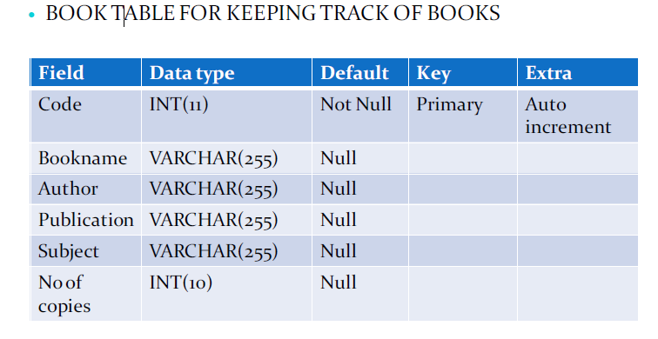

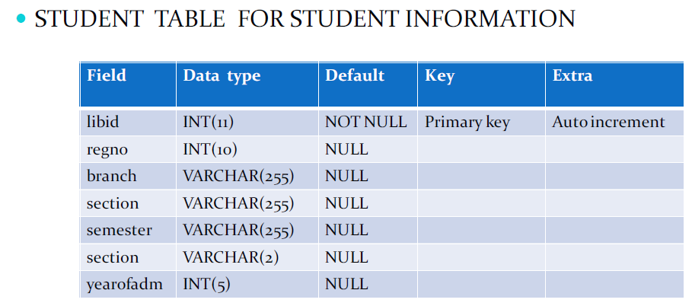

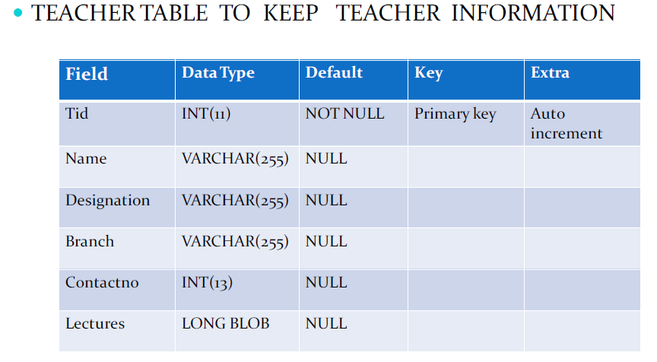

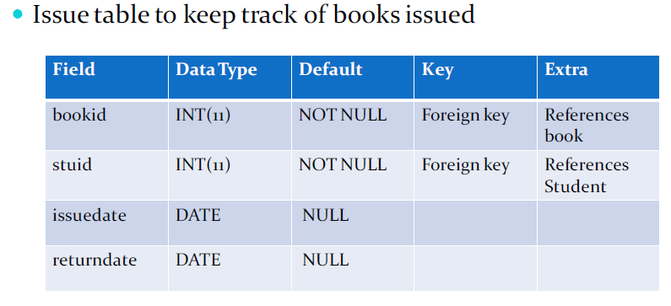

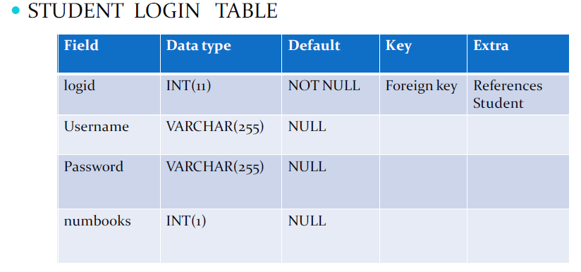

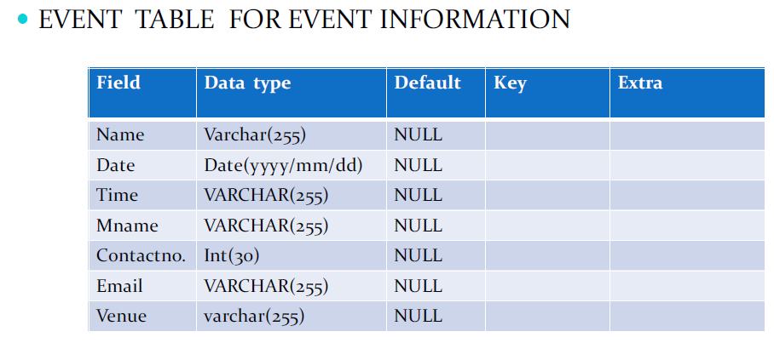

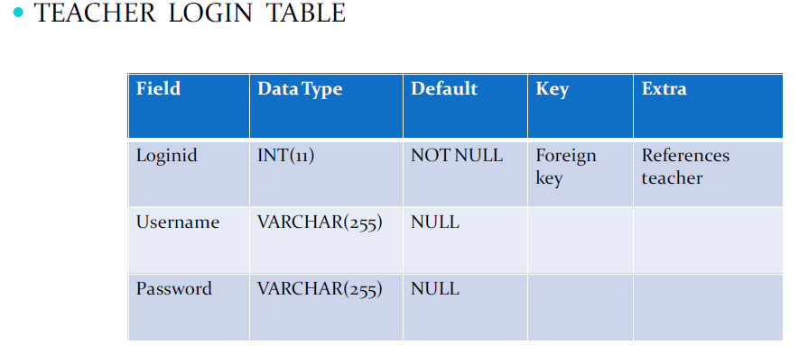

**3.3 DATA FLOW DIAGRAMS**

DATA FLOW DIAGRAM FOR TEACHER LOGIN

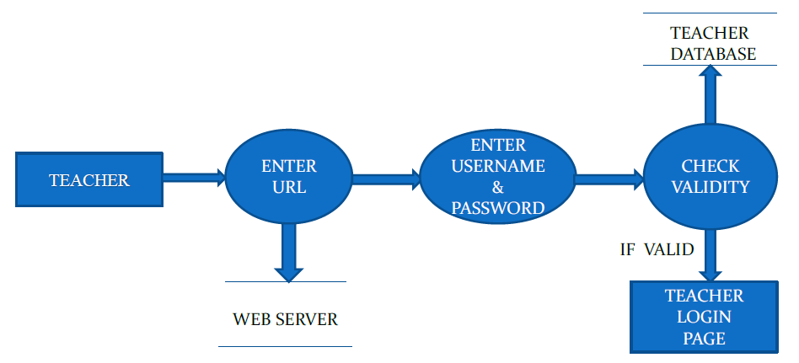

TEACHER ENTER URL ENTER USERNAME & PASSWORD CHECK VALIDITY WEB SERVER TEACHER DATABASE TEACHER LOGIN PAGE IF VALID

After entering to the home page of the website , teacher can choose the TEACHER LOGIN option where they are asked to enter username & password , and if he/she is a valid user then a teacher login page will be displayed.

DATA FLOW DIAGRAM FOR STUDENT LOGIN

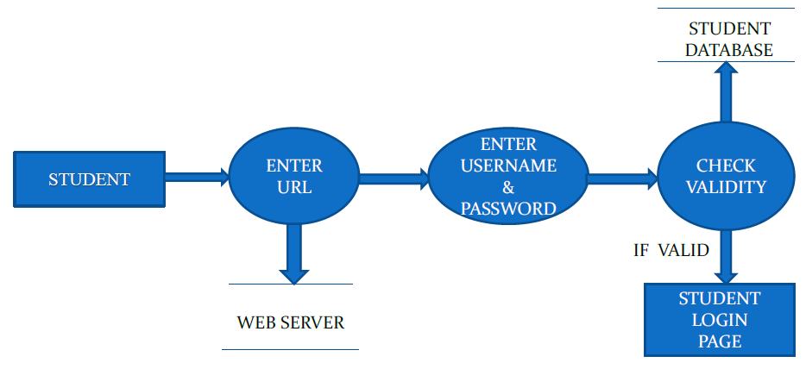

After entering to the home page of the website , student can choose the STUDENT LOGIN option where they are asked to enter username & password , and if he/she is a valid user then a student login page will be displayed.

DATA FLOW DIAGRAM FOR BOOK ISSUE

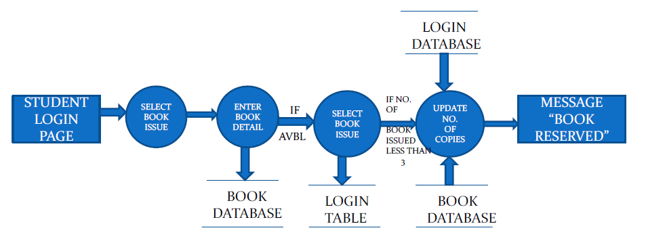

It is a 2nd level Data Flow Diagram where after entering STUDENT LOGIN page he/she can select a book issue option where after entering the book detail, he/she can select the book issue option and if the maximum no of books issued limit is not crossed then a request will be sent to the librarian who will approve the book issue.

DATA FLOW DIAGRAM FOR BOOK SEARCH

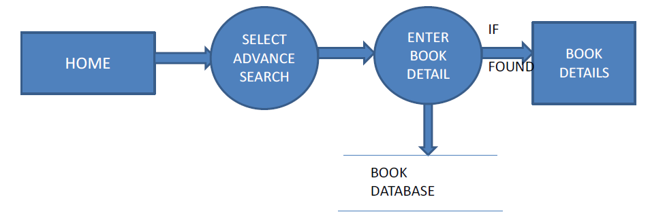

After the home page login there will be an option of the book search where after entering book detail like author name, publication, book name etc book details will be displayed.

DATA FLOW DIAGRAM FOR ACCOUNT CREATION

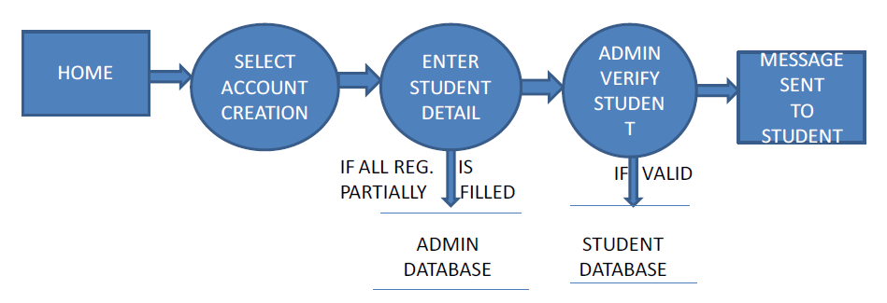

After the home page login there will be an option of CREATE AN ACCOUNT where after entering student detail ,if all the fields are filled then a request will be sent to the librarian who will approve him as a registered member of the library.

CHAPTER 4

# 4.1 SYSTEM TESTING

The aim of the system testing process was to determine all defects in our project .The program was subjected to a set of test inputs and various observations were made and based on these observations it will be decided whether the program behaves as expected or not.

Our Project went through two levels of testing

1.Unit testing

2.integration testing

**4.2 UNIT TESTING**

Unit testing is undertaken when a module has been created and succesfully reviewed .In order to test a single module we need to provide a complete environment ie besides the module we would require

* The procedures belonging to other modules that the module under test calls
* Non local data structures that module accesses
* A procedure to call the functions of the module under test with appropriate parameters

Unit testing was done on each and every module that is described under module description of chapter 4

1. Test For the admin module

* Testing admin login form-This form is used for log in of administrator of the system.In this we enter the username and password if both are correct administration page will open other wise if any of data is wrong it will get redirected back to the login page and again ask for username and password

Student account addition- In this section the admin can verify student details from student academinc info and then only add student details to main library database it contains add and delete buttons if user click add button data will be added to student database and if he clicks delete button the student data will be deleted

* Book Addition- Admin can enter details of book and can add the details to the main book table also he can view the books requests .

2. Test for Student login module

* Test for Student login Form-This form is used for log in of Student .In this we enter thelibraryid, username and password if all these are correct student login page will open other wise if any of data is wrong it will get redirected back to the login page and again ask for libraryid, username and password.
* Test for account creation- This form is used for new account creation when student does not fill the form completely it asks again to fill the whole form when he fill the form fully it gets redirected to page which show waiting for conformation message as his data will be only added by administrator after verification.

3. Test for teacher login module-

* Test for teacher login form- This form is used for logg in of teacher .In this we enter the username and password if all these are correct teacher login page will open other wise if any of data is wrong it will get redirected back to the login page and again ask for username and password.

**4.3 INTEGRATION TESTING**

In this type of testing we test various integration of the project module by providing the input .The primary objective is to test the module interfaces in order to ensure that no errors are occurring when one module invokes the other module.

CHAPTER 5

# 5.1 CONCLUSION & FUTURE SCOPE

This website provides a computerized version of library management system which will benefit the students as well as the staff of the library.

It makes entire process online where student can search books, staff can generate reports and do book transactions. It also has a facility for student login where student can login and can see status of books issued as well request for book or give some suggestions. It has a facility of teacher’s login where teachers can add lectures notes and also give necessary suggestion to library and also add info about workshops or events happening in our college or nearby college in the online notice board.

There is a future scope of this facility that many more features such as online lectures video tutorials can be added by teachers as well as online assignments submission facility , a feature

Of group chat where students can discuss various issues of engineering can be added to this project thus making it more interactive more user friendly and project which fulfills each users need in the best way possible

CHAPTER 6

# REFERENCES

▪ http://www.w3schools.com/html/html_intro.asp

▪ http://www.w3schools.com/css/css_background.asp

▪ http://www.w3schools.com/js/js_datatypes.asp

▪ http://www.w3schools.com/sql/sql_insert.asp

▪ http://www.w3schools.com/sql/sql_update.asp

▪ http://www.w3schools.com/php/php_forms.asp

▪ Fundamentals of software engineering by Rajib mall, PHIlearning

▪ Web development and application development by Ivan Byross BPB publications